6th December 2021
To all MPs
Update on the Arthur Labinjo-Hughes review
Dear Colleagues
The whole nation is distraught at Arthur’s tragic and horrific murder. It is impossible to imagine how any adult could commit such evil acts against a child looking for love and protection, let alone members of their family.
No child should ever be exposed to so much evil. No family or community should have to live through the pain of losing a child to such sadistic cruelty.
I am determined to get to the truth, expose what went wrong and take any action necessary to protect children. I also want to make clear that police officers, social workers, health workers and others go to work each day to try to make things better. They deserve our thanks.
Since the horrendous deaths of Peter Connelly, Daniel Pelka and others, the Government has established stronger multi-agency working, putting a shared and equal duty on police, councils and health in local areas to work together to safeguard and promote the welfare of children.
The public - standing shoulder to shoulder with Arthur’s loved ones, his friends, his community - deserve to know why, in this rare case, things went horrifyingly wrong, and what more could be done to prevent abuse such as this happening again in future.
This weekend I asked the chair of the National Child Safeguarding Practice Review Panel, Annie Hudson, to work with leaders in Solihull to deliver a national, independent review of Arthur’s death. This will encompass local government, as well as those working in the police, health and education sectors.
Officials in my Department are in close contact with the Solihull Safeguarding Partnership, which is grateful for the support offered and agree with this approach as the best way to identify whether there are any gaps that need to be addressed.
This review will focus specifically on Arthur’s case. But I also want to make certain we have looked at how the relevant local agencies in England are working now, including how they are working together.
This is why I have also asked Ofsted, the Care Quality Commission, HM Inspectorate of Constabulary and Fire & Rescue services and HM Inspectorate of Probation to lead a Joint Targeted Area Inspection. I have asked that each of these inspectorates be involved because of the range of local services which have been involved in Arthur’s and his family’s life during the preceding months, and this joined up approach will be the most effective way to prevent more cases like this. These inspectorates have met today to plan this work and field work will begin next week.
This joint inspection will consider where improvements are needed by all the agencies tasked with protecting children in the Solihull area, so that we can be assured that we are doing everything in our power to protect other children and prevent such evil crimes.
Over the coming days, we will publish terms of reference and timelines for this national review and local inspection.
Ahead of that, more widely, we are already investing heavily to help the legions of dedicated professionals on the frontline deliver the care that we all know every child deserves. Since the Spending Review in 2019 there have been year-on-year real terms increases for local government – as well as the unprecedented additional £6 billion funding provided directly to councils to support them with the immediate and longer-term impacts of COVID-19 spending pressures, including children’s social care.
We must make sure that those who would do wicked acts to children face justice. We must do absolutely everything in our power to protect vulnerable young children from harrowing and evil abuse.
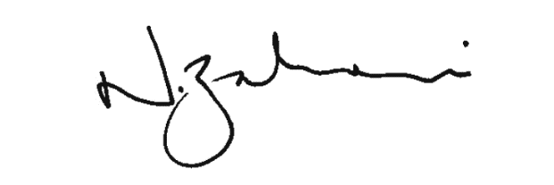

Rt Hon Nadhim Zahawi MP
Secretary of State for Education

